Easy-to-read version

EU COHESION POLICY AND WHAT TO DO WHEN RIGHTS HAVE BEEN BREACHED
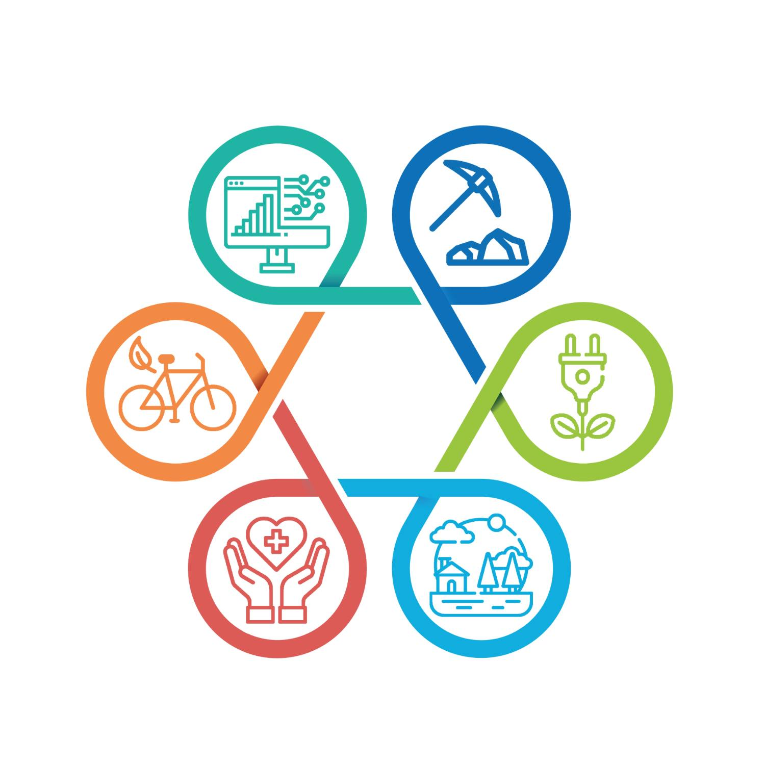

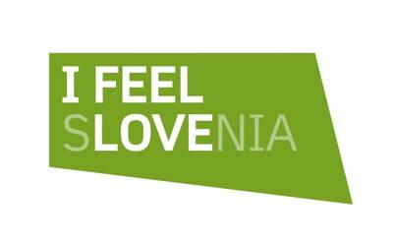
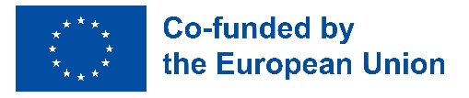

The Ministry of Cohesion and Regional Development has prepared a document presenting relevant information about the European Union and how to make a complaint when rights have been breached.
This document presents the following information:

About the European Union:
- What is the European Union?
- What are the tasks of the European Union?
- How does the European Union make our lives better?
- What are the documents that the European Union should respect in its actions?

About the complaint and the breach of rights:
- How is the EU Cohesion Policy implemented?
- When can you make a complaint?
- Who can you make a complaint to?
- What will happen to your complaint?
- How can you make a complaint?
- When can you find help when making a complaint?

What is the European Union?
The European Union is a group of 27 countries in Europe.
Slovenia is also a Member State of the European Union.
We use the abbreviation ‘EU’ to refer to the European Union.
The main goals of the European Union are:
- preservation of peace,
- promotion of economic and social cooperation,
- connecting people who live in the European Union.
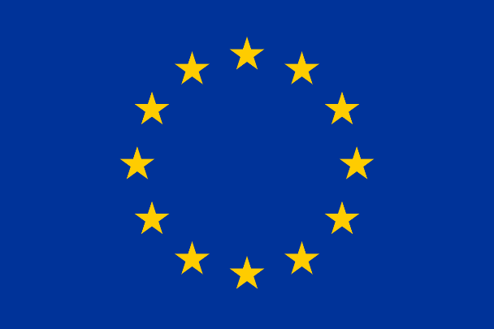
the European flag

The European Union has many tasks.
The EU makes sure that everyone respects the same values.
A value is something that is considered as good and right.
The EU makes sure that human rights are respected.
These are the fundamental rights of all people.
The European Union makes sure that all Members States are democratic.
This means that the people participate in elections and decide who will lead the country.
The EU makes sure that everyone respects the rule of law and that all citizens are equal before the law.
Laws are documents where rules are written down.

The EU makes sure that we all respect the different cultures and traditions of the people who live in the EU Member States.
More information about the European Union in Easy-to-Read format

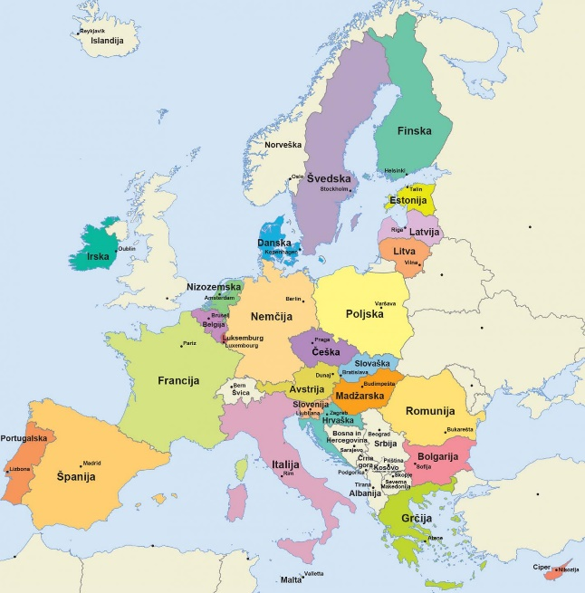
Map of EU Members States

How does the European Union improve our lives?
The EU has established the EU Cohesion Policy.
A policy is a list of plans of how the European Union wishes to work.
The Cohesion Policy is made up of plans that are interconnected.
If the plans are connected, they help improve our lives.
EU Cohesion Policy aims to:
- reduce economic and social disparities between the Member States,
- reduce economic and social disparities between individual territories within each Member State,
- promote economic and social cooperation between EU Member States,
- encourage EU Member States to help each other,
- implement important EU documents that enshrine our most fundamental rights.
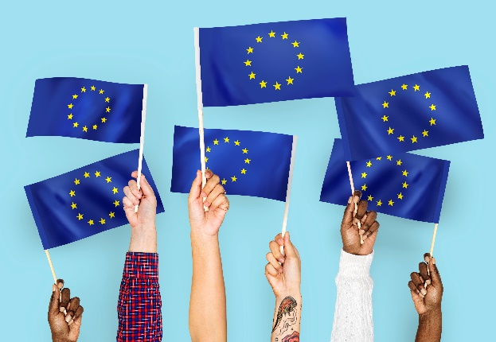 | The picture shows hands holding the European flag.
Slovenia is part of the European Union.
Slovenia should implement the EU Cohesion Policy.
The European Union helps Slovenia implement the EU Cohesion Policy.
EU Cohesion Policy implementation means that:
- Slovenia helps form the EU’s aims and objectives in EU Cohesion Policy implementation,
- Slovenia makes up a plan on how to realise the objectives of EU Cohesion Policy implementation,
- Slovenia makes sure that the EU Cohesion Policy funds are spent for realising the EU’s objectives,
- Slovenia establishes whether the EU Cohesion Policy objectives were well-implemented.

The Ministry of Cohesion and Regional Developments is the authority responsible for the implementation of the EU Cohesion Policy in Slovenia.

REPUBLIC OF SLOVENIA
MINISTRY OF COHESION AND REGIONAL DEVELOPMENT

The EU makes sure that we all enjoy equal rights and that we all live well.
This is why the EU must take into account two important documents in its activities.
Documents are, for example:
laws, identity cards, medical reports, etc.

The European Union must take into account the following documents:

- The Charter of Fundamental Rights of the European Union
We’ll call this document 'the Charter'.
The Charter brings together the most important rights enjoyed by citizens of the EU, for example:
  - right to life,
  - prohibition of torture,
  - right to liberty and security,
  - right of integration of persons with disabilities.
EU Members States should make sure that all citizens of the EU enjoy the rights listed in the Charter.

Charter of Fundamental Rights of the European Union

- United Nations Convention on the Rights of Persons with Disabilities
We’ll call this document 'the Convention'.
The Convention says that all persons with disabilities enjoy equal human rights and fundamental freedoms.
Human rights and fundamental freedoms are the most important rights enjoyed by all people.
All human beings get them at birth and enjoy them for the rest of their lives.
Such rights and freedoms are, for example, the right to life, the right to security and the right to liberty.
The Convention also sets out specific rights given to people with disabilities.

United Nations Convention on the Rights of Persons with Disabilities
Easy-to-Read version of the United Nations Convention on the Rights of Persons with Disabilities
(Available only in Slovene.)

Slovenia has adopted its Cohesion Policy Programme for the period 2021-2027.
Slovenia’s Cohesion Policy Programme says that Slovenia must respect the Charter and the Convention.
We have developed a plan on how Slovenia will respect the provisions of the Charter and the Convention.
The plan defines how Slovenia will respect the Charter and the Convention.
Slovenia must make sure that the provisions of the Charter and the Convention are respected.

Website dedicated to the implementation of Slovenia’s Cohesion Policy Programme 2021-2027

Plan for respecting the Charter and the Convention
(Available only in Slovene.)
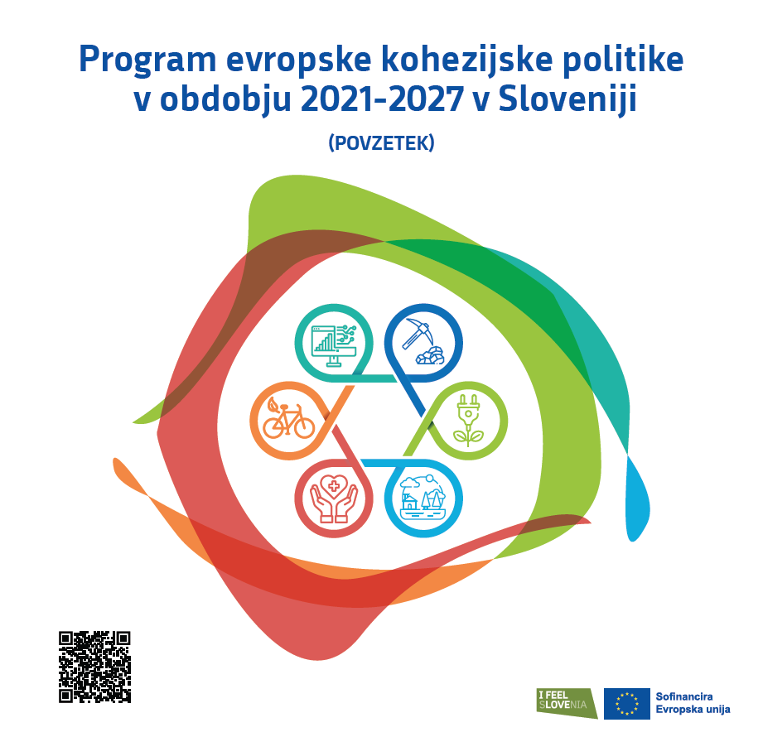
The picture shows the front page of the summary of Slovenia’s Cohesion Policy Programme 2021-2027.

How is the Cohesion Policy implemented?

The Ministry of Cohesion and Regional Development receives money from the European Union.

The Ministry uses the EU money for the implementation of the EU Cohesion Policy.

The Ministry can get the money from various Funds.

For example, the European Social Fund Plus,
The European Fund for Regional Development,
The Cohesion Fund, the Just Transition Fund …

The Funds provide money to help implement the EU Cohesion Policy in EU Member States.

The money from an individual Fund can be used for a specific purpose.

This way, the European Union makes sure that the money from the Funds is used to support those EU Member States that most need the money.

By giving the support, the EU makes sure that all the states develop.
The EU makes sure that all citizens live well.
The Ministry of Cohesion and Regional Development distributes the money it receives from the EU for Cohesion Policy implementation to other ministries.
If a ministry wants to use the money for Cohesion Policy implementation, it prepares a call for proposals.
A call for proposals is a document.
In the call for proposals, the ministry sets out what the money will be spent on.
The call for proposals identifies the potential beneficiaries.
The applicants should know how to use the money to benefit people and for EU Cohesion Policy implementation. Slovenia has implemented numerous projects with the help of EU Cohesion Policy money.  Slovenia has implemented over ten thousand projects.  The projects were managed by companies, municipalities, organisations, and individuals. For example, Urban Municipality Celje received money for setting up cycle paths.  With the projects, the municipality implemented the EU Cohesion Policy.  With the help of EU money, Urban Municipality Celje has built several cycle paths. | 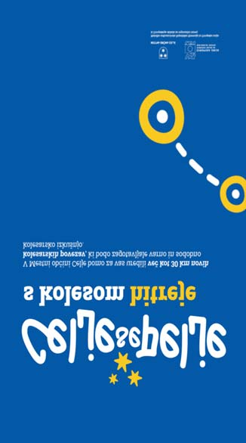  The picture of a publicity banner advertising cycle paths in Celje.
You can make a complaint if your rights under the Charter and the Convention have been breached.

In Cohesion Policy implementation, we should respect the rights enshrined in the Charter and the Convention.

If the rights under the Charter and the Convention are not respected, you can make a complaint.

You can report a breach of the rights when someone does something wrong and when you want to inform somebody of the breach.

You can make a complaint with the Ministry of Cohesion and Regional Development.
The Ministry is responsible for making sure that Slovenia implements the EU Cohesion Policy.

More information about the Ministry of Cohesion and Regional Development

Who can make a complaint?

Anyone participating in EU Cohesion Policy implementation in Slovenia can make a complaint.

Anyone who believes that the rights under the Charter and the Convention have been breached can make a complaint.

A complaint can be made by:
- those who have submitted a project under a call for proposals,
- those whose project has been selected under a call for proposals,
- those who have participated in a project.

You can report a breach of rights regarding:
- the steps in which the EU money was awarded to someone,
- how the money awarded for a certain project was spent.

Example:
An institution organised educational training.
The training was organised and paid for with the help of the EU Cohesion Policy Funds support.
Ana wanted to attend the training.
Ana uses a wheelchair.
The training took place on the first floor. There is no lift.
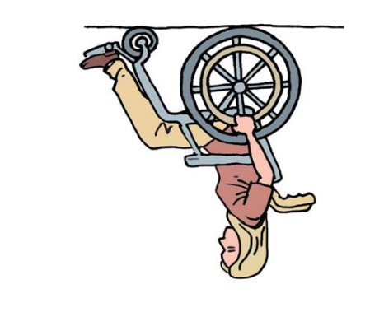
Ana could not attend the training because she could not reach the room where the training took place because she uses a wheelchair.
The institution did not respect the Convention, so Ana made a complaint.

You can make a complaint if the money comes from one of the following EU Funds:
- European Regional Development Fund,
- European Social Fund Plus,
- Cohesion Fund and
- Just Transition Fund.

The decision regarding the complaint will be made by the people who are responsible for the implementation of Slovenia’s Cohesion Policy Programme 2021-2027.

We say that these people make up the Managing Authority.

What will happen to your complaint?
Your complaint will be treated by the people who represent the Managing Authority.

They will establish whether the complaint is related to a matter on which they can decide.

They will check all the evidence on the breach of rights.

If they are not authorised to decide on the matter, they will advise you on who you can turn to and who is competent to make a decision regarding your complaint.

List of institutions responsible for the protection of human rights in Slovenia

If the Managing Authority establishes that rights have been breached, it notifies the people who make up the Monitoring Committee of Slovenia’s Cohesion Policy Programme 2021-2027.
The Managing Authority informs the Monitoring Committee about how the rights have been breached and what the violators should do to stop breaching the rights.

The Managing Authority does not inform the Monitoring Committee of who breached the rights and who reported the breach.

How can I make a complaint?

- You can submit your complaint on an e-form:

Submit your complaint via e-form

- You can fill in the form on your computer and send it by e-mail to

gp.mkrr@gov.si

- You can print the form, fill it in by hand and send it to:
Managing Authority of Slovenia’s Cohesion Policy Programme 2021-2027
Ministry of Cohesion and Regional Development
Kotnikova 5
1000 Ljubljana
Slovenia

Do you need help with making a complaint?

If you need help with making a complaint, you can reach us at
080 20 23
between 9:00 and 12:00
from Monday to Friday.
The call is free of charge.

Additional information about our assistance

This is Ema.
Ema can help you. You can reach Ema at the website www.evropskasredstva.si.

Other relevant information

Even if you have already made a complaint with the Managing Authority, you can also make a complaint elsewhere.

You can make a complaint in Slovenia as well as with the European Commission.

You can also make a complaint against the person or organisation who breached your rights.

List of institutions responsible for the protection of human rights in Slovenia

About the information in this document

Information in this document is given in an easy-to-read format.
The information is meant for everyone who has trouble treading and difficulty understanding the content.
The document follows the recommendations for writing in an easy-to-read format.
The recommendations are published in Lahko je brati: Nasveti za lahko branje v slovenščini, 2. zvezek.
This is why we use the Slovenian easy-to-read sign:
© Slovenian Sign for Easy Reading: the Risa Institute.
The document also follows the European Union’s recommendations for easy reading.
The recommendations are published in the book Information for All.
That is why we also use the European easy-to-read logo:
© European Easy-to-Read Logo: Inclusion Europe.
The document uses photos and illustrations which are available for free on the Internet.
We got the photos and illustrations also on the website Freepic and Lahko je brati.
EU Cohesion Policy and what to do when rights have been breached.
Adapted by: Živa Jakšić Ivačič
Expert review: mag. Jerneja Stanišič and
mag. Petra Potrpin Bertole.
Test readers: Blaž Kern, Aljaž Bohinc Hušič,
Andrej Tehovnik and Darko Pejić.
Expert support for test readers:
Vlasta Stupar and Kristina Stražišar.
Linguistic review: Marjanca Scheicher
Designed by: Oblikovalni studio 76, Marko Bradica s. p.
Published by: Ministry of Cohesion and Regional Development
For the publisher: Dr Aleksander Jevšek, Minister
Digital edition.
Information available at:
https://evropskasredstva.si/lahko-branje/
Ljubljana, 2023

Cataloguing in Publication (CIP) prepared by the National and University Library in Ljubljana
COBISS.SI-ID 169376259
ISBN 978-961-96425-1-1 (PDF)

