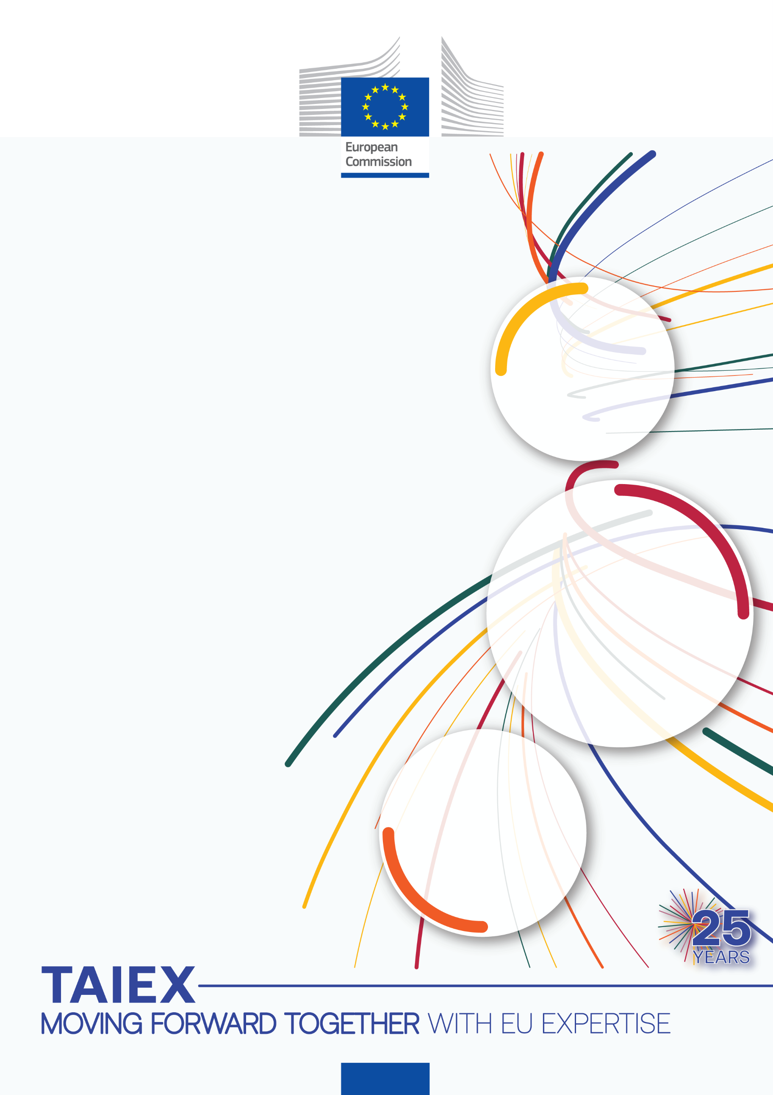

TAIEX-REGIO Peer2Peer workshop on the preparation of the final report on EU Solidarity Fund assistance after the floods in Slovenia in August 2023







TAIEX expert mission on post-disaster recovery (EU Solidarity Fund) took place between 27 and 28 May in Ljubljana. The event was organised by the Directorate-General for Enlargement and Eastern Neighbourhood (DG ENEST) in the scope of the TAIEX instrument and hosted by the Ministry of Cohesion and Regional Development.
The workshop, held as a TAIEX-REGIO Peer2Peer meeting, was designed to facilitate the preparation of the final report on the implementation of the financial contribution from the EU Solidarity Fund (EUSF) following the devastating floods that hit Slovenia in 2023. Overall, the workshop aimed to support the exchange of experience in financial management and control, with particular emphasis on the preparation of the final implementation report and on the audit procedures related to the EUSF implementation.
The event brought together representatives of the relevant Slovenian institutions and two experts from Croatia, i.e., Ms Irena Križ Šelendić, Director-General of Directorate for Energy Efficiency in the Buildings Sector, European Union Projects and Programmes, and Ms Maja Buterin Kranjec, Head of Sector for Coordination of the National Recovery and Resilience Plan and European Union Assistance Programme, both contributing their insights and technical expertise.
On the first day, participants looked into the institutional and legislative framework governing the EUSF in Croatia. They learned more about the impact and scope of damage, and the relevant regulatory provisions and explored both the political and technical approaches to reconstruction, including the build back better principle. Discussions also addressed the EUSF implementation system, its operational structures, and the respective roles of bodies responsible for implementing and coordinating the operations.
A substantial part of the first day was dedicated to examining the EUSF management and control systems, including procedural requirements, monitoring arrangements, and risk mitigation measures. Participants also analysed national and European audit procedures, including the checks carried out by the European Court of Auditors and the European Commission. The day concluded with an in-depth discussion and a summary of key takeaways.
On the second day, participants focused on the preparation of the final report on the implementation of the financial contribution from the EUSF. They examined a range of practical challenges, ranging from data collection, partially implemented operations, treatment of costs exceeding the amount made available, interest rate provisions, and ineligible expenditure. The structure of the final implementation report was presented in detail, covering the overview of implementation, the establishment of management and control systems, and the implementation of operations.
Particular emphasis was also placed on preventive measures aimed at mitigating future risks, compliance with the EU legislative framework on disaster management, and measures to ensure environmental protection and climate resilience. During the final session, participants exchanged experiences and knowledge gained, identifying key lessons for future actions.
The event concluded with a discussion on the lessons learned, highlighting the importance of the effective management of EUSF financial contribution for successful post-disaster recovery.

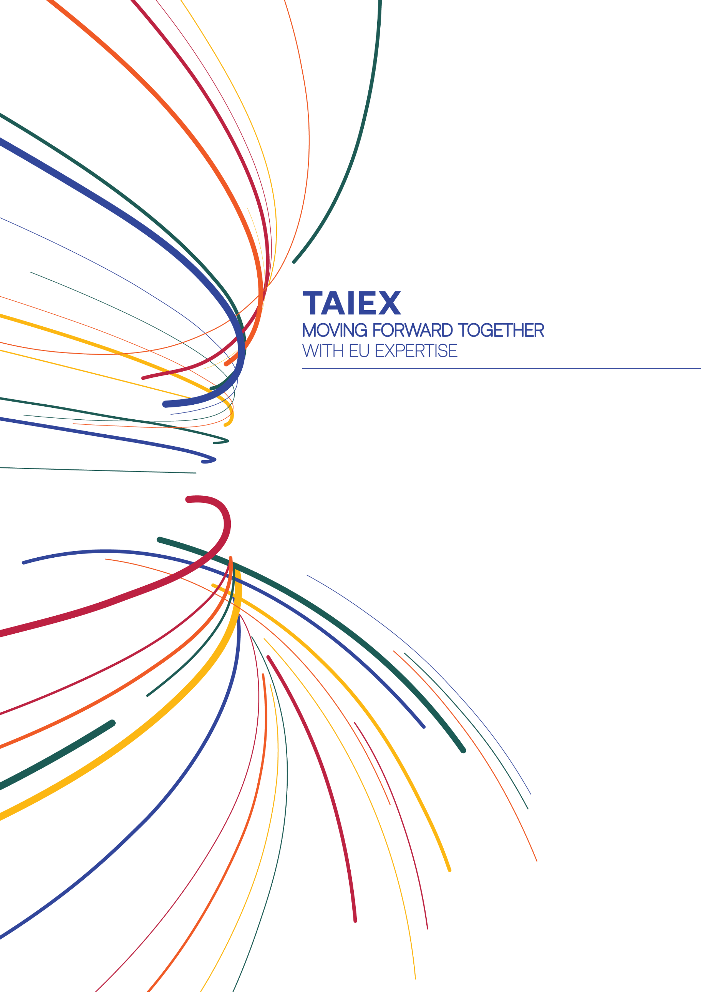


More information on
TAIEX

More information on
TAIEX-REGIO Peer2Peer





REGIO-PEER2PEER@ec.europa.eu

facebook.com/EUNEAR

near-taiex@ec.europa.eu

facebook.com/EUinmyregion

ec.europa.eu/regional_policy/p2p
ec.europa.eu/taiex

@RegioAdmCap | #EUTaiex #RegioP2P

@eu_near@EUinmyRegion

